Table of Contents

- General
- Production
  - Resin
  - Surface Smoothness
  - Cleaning and Packaging
  - Pressure Ratings
  - Fire Data
  - Products
    - Pipe
    - Fittings
    - Valves
    - Flow Meters
- Hanging Criteria
- Project Execution
  - Material Storage
  - Manufacture Representation
    - Training
- Welding Techniques
  - Conventional Butt Fusion
    - Shop 4 Miniplast
  - Non-Contact IR Fusion
    - UF2000 Series
    - SP Series
5.3 Socket Fusion
- Suggested Work Facilities
6.1 Tool Storage
- Test and Inspection Procedures
  - Joint Inspection
  - Pressure Test

Appendix A: Purity Data

1. General
The following is the formal submittal from Asahi/America, Inc. for the supply of PolyPure piping systems. The submittal is inclusive for all dimensions offered.

2. Production

2.1 Resin
All pipe, fittings, valves and flow meters shall be made from a random copolymer polypropylene-ethylene resin. The resin shall be Borealis RA130E with a chemical structure of C2H3CH3.
Borealis RA130E resin shall comply with food contact requirements as outlined in the Code of Federal Regulations Title 21 (2001) 177.1520 (a)(3)(i)(c)( 1), (b) and (c)3.1a Olefin polymers. In addition, the resin and final product shall have the following physical properties:

Property | Test Standard | Unit | PolyPure Result
Density | Din 53479 ASTM D 792 ISO/R 1183 | g/cm3lb/ft3 | 0.9-0.9156.6
MFI | DIN 53735190/5230/2.16230/5 | g/10min | 0.50.31.25
Tensile stress at yield | DIN 53455 | N/mm2psi | 402625
Elongation at yield | ISO/R 527 | % | 12
Ultimate strength | DIN 53495  ISO/R 527  ASTM D 638 | N/mm2  psi | 40  5800
Elongation at break | DIN 53457  ASTM D 638 | % | 50
E-modulus (tensile strength) | DIN 53457  ISO 178  ASTM D 1708 | N/mm2  psi | 750  108750
E-modulus (bending test) | DIN 53457  ASTM D 790 | N/mm2  psi | 700  101500
Impact strength notched  acc. Charpy | DIN 53453  ISO 179/2C | kJ/m2 | 20
Crystalline melting point | DIN 53736 | °C  °F | 150-154  302-309
Linear expansion coefficient | DIN 53453 | l/K | 1.5 x 10 (4)
Thermal conductivity  20°C - 150°C | DIN 52612  TMA  ASTM D 177 | W/mK  BTU-in  hr-ft(2)-F° | 0.24  164
Volume resistance | DIN 53482  ASTM D 177  IEC Publ. 93 | Ohm cm | > 10 (16)
Physiologically non-toxic |  |  | yes
FDA approval |  |  | yes
Abrasion resistance | DIN 53754 | mg/100 cycles | 13.6
Weldability |  |  | IR non contact, butt, or socket
UV resistance |  |  | not resistant

2.2 Surface Quality
The following table indicates the surface roughness measurements of PolyPure sizes ½” – 2” according DIN 4768 (axial and radial direction).

Dimension | Ra | Rt
OD 20 – 40 mm | ≤ 1.5µm | ≤ 6µm
OD 50 – 110 mm | ≤ 0.8µm | ≤ 3µm

2.2.1 Surface Quality Inspection
The inner surface roughness testing procedure for ½” through 2” material is performed, according our minimum required quality control, 1 time per shift.

2.3 Cleaning and Packaging
The following cleaning and packaging methods shall be used during the production of PolyPure pipe, fittings, and valves

2.3.1 Pipe
Manufacturing: On specific designated extrusion equipment
Packaging: Immediately after production
Packaging style: PE Film supported by caps on each end with pipe bagged in the following quantities:

Dimension | Packaging
20mm (1/2") | 5 piece in one PE bag
25mm (3/4") | 4 piece in one PE bag
32mm (1") | 3 piece in one PE bag
40mm (1 1/4") and Above | 1 piece in one PE bag

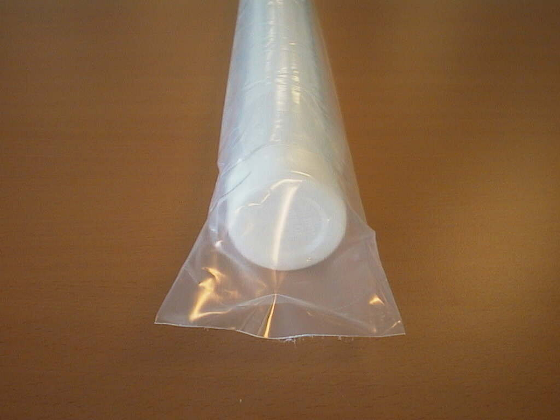
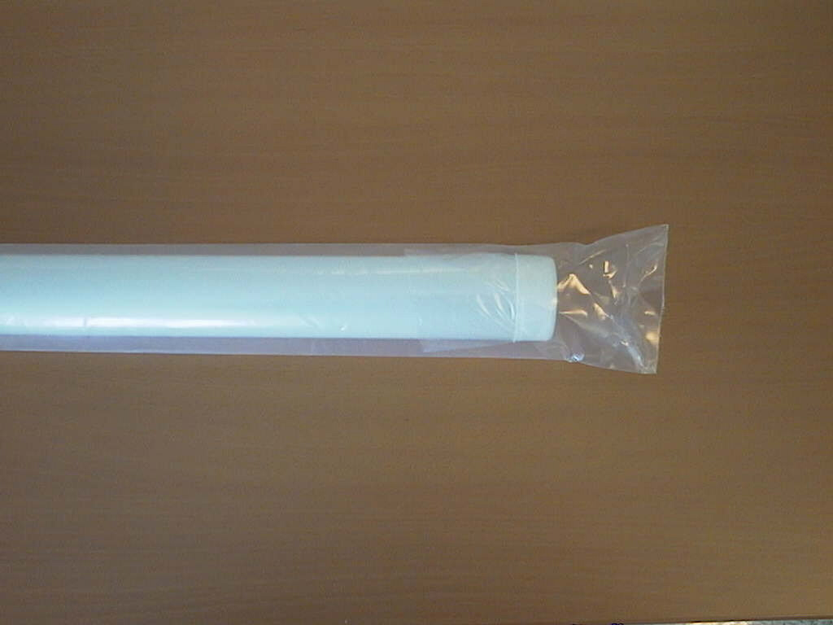
The PE-film is closed on both ends. Packaging for transport will be fixed with customers for each shipment (depending on quantity).

2.3.2 Fittings
Cleaning: Cleaned with UPW and dried with hepa filtered air
Cleaning in cleanroom class 100 area
Packaging: In cleanroom class 100 area
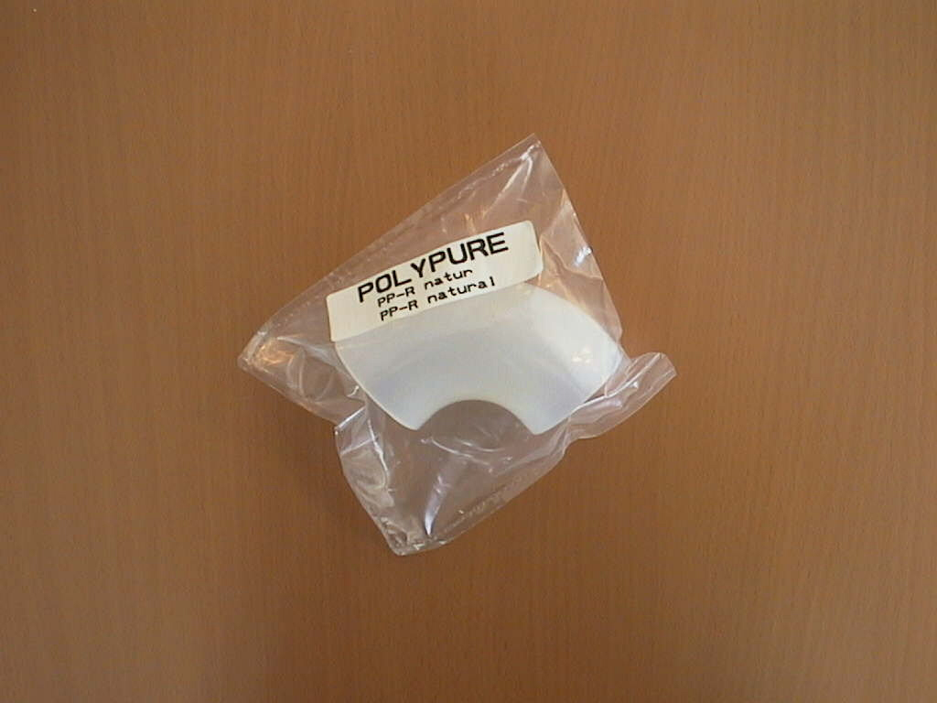
Packaging style: Single packed in a PE/nylon unpigmented composite bag. The bags are purged with clean, dry nitrogen (class 5.0). Packed in cardboard boxes according to the packaging list.
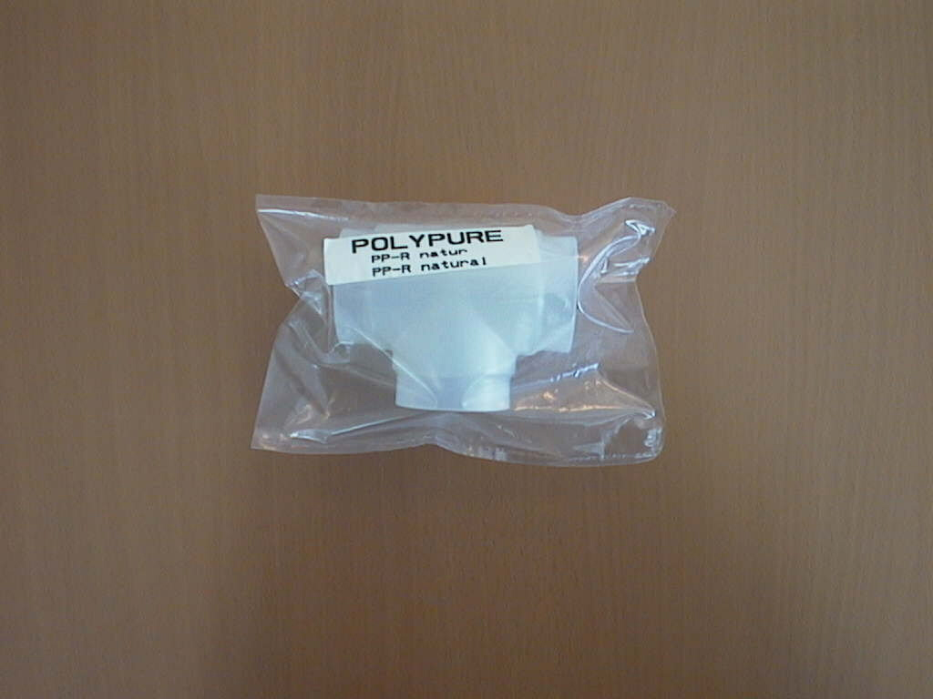

2.3.3. Valves
Cleaning: Cleaned with UPW and dried with hepa filtered air
Cleaning in cleanroom class 100 area
Packaging: In cleanroom class 100 area
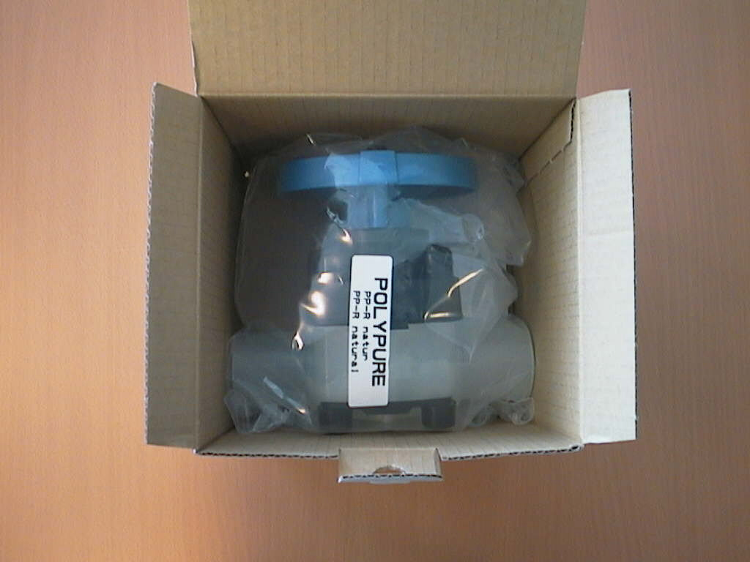
Packaging style: Single packed in a PE/nylon unpigmented composite bag. The bags are purged with clean, dry nitrogen (class 5.0). The valves are single packed in cardboard boxes.

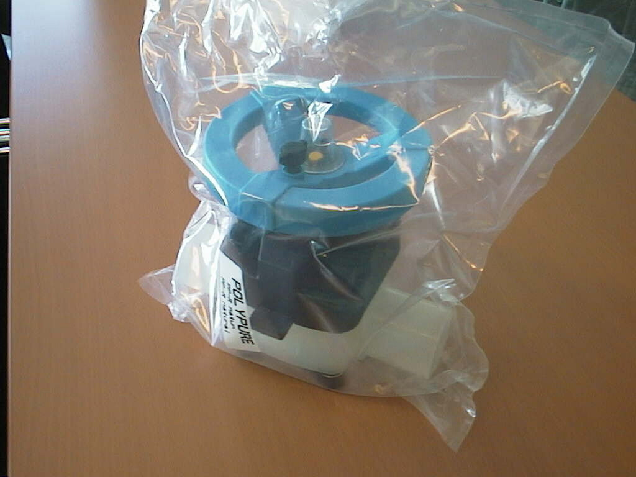

2.4 Pressure Rating (pipe and fittings)

150 PSI at 73.4°F for sizes ½” - 4” according to ASTM D-2837-85

Valve pressure ratings are based on the valve material and style. See valve catalogs for ratings.

Permissible System Working Pressure

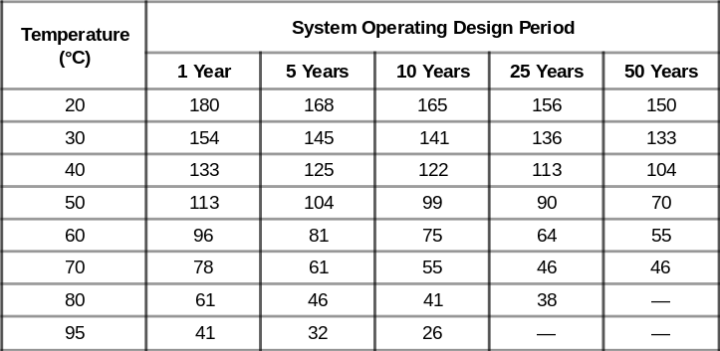
2.5 Fire data

Polypropylene is in general UL94-HB classified. The fire classification registration of PolyPure is acc. DIN 4102 and ÖNORM B3800 B2, which means normal combustible. Registration acc. UL94 or ASTM E84 is not available for PolyPure.

2.6 Products

2.6.1 Pipe
Pipe shall conform to the requirements of ASTM D-2837-85 for establishing a hydrostatic design basis and be produced on dedicated extrusion equipment. In addition, the pipe shall have a standard dimensional ratio of SDR 11 and be pressure rated to 150 psi at 73.4° F for all diameter sizes (½” through 4” nominal diameter).

2.6.2 Fittings
Pressure fittings shall conform to the same requirements as outlined for piping. In addition, pressure fittings, ½” through 4”, shall be injection molded on dedicated equipment and supplied individually packaged in a PE bag.

2.6.3 Valves
Type 342 Spigot Diaphragm Valves:
½”-2” (20mm –63mm) shall be the type 342 of the PURAD system. The Valves shall have a PolyPure body and a diaphragm of PTFE with EPDM backing or EPDM. Valves will be spigot single body design. Top Works must include integral lockout device on the handle and position indicator.

Type 342 Flanged Diaphragm Valves:
½” – 2 ” shall be type 342 with stub end and backing ring IR welded onto both sides. Top Works must include locking device on the handle and position indicator.

Flanged Diaphragm Valves:
3” - 4” shall be type 14 single Proline PP body design with flanges molded as part of the body. Diaphragm shall be PTFE with EPDM backing or EPDM. Top Works must include locking position indicator.

Type 343 Reduced Dead Leg Valve:
½” x ½” through 2” x 2” (20mm x 20mm through 110mm x 63mm) reduced dead leg (zero dead leg) valves shall be Type 343 Style from the PolyPure System. Valves shall be made of PolyPure resin. Valve bodies are to be unibody, molded design with a full 150 psi rating at 70ºF. All metal nuts and bolts must be capped or covered to reduce metal exposure. Top Works must include integral lockout device on the handle and position indicator. (Consult Factory for Availability of Molded T-343)

Diaphragm valves are provided as standard with cleaning and packaging as outlined in section 2.3.3
Ball Valves:
½” – 2”shall be true union style with butt-fusion ends. Ball valves shall be rated at 150 psi at 73.4° F (23°C). For elevated temperatures consult manufacturer. Valves shall have Viton® seals with PTFE seat ring.

Valves shall be provided as standard dry packed, free of silicon lubricant. Optional cleaning and packaging in class 1000 cleanroom shall be available upon request.

Butterfly Valve:
1 1/2" - 4" shall have a lined body design and provide a bubble-tight seal with only the liner and disk as wetted parts. The disk shall be pigmented PP and have double O'ring seal on top and bottom trunnions of the same material as the liner. Standard body material shall be PVC with Pigmented PP as an option.

Optional cleaning and packaging in class 1000 cleanroom shall be available upon request.

2.5.4 Flow Meters:
All flow meters shall be Universal vortex shedding style and made of natural PP resin. Flow meters are to be provided with 4-20 mA or frequency pulse output. All meters must be wet bench calibrated. Calibration certificates are to be provided with each flow meter. Meters shall be wafer style for connection between two flanges

3. Hanging Criteria
It is recommended to hang all PolyPure in a manner that prevents point loads. Hangers that hold 360 degrees around the pipe are recommended over U-Bolt style hangers.

Support Spacing Recommendation (units are in feet)
Nominal  Size | 68° F  20° C | 86° F  30° C | 104° F  60° C | 122° F  50° C | 140° F  60° C | 158° F  70° C | 176° F  80° C
1/2” | 3 | 2.5 | 2.5 | 2 | 2 | 2 | 2
3/4” | 3 | 3 | 2.5 | 2.5 | 2.5 | 2.5 | 2
1” | 3.5 | 3 | 3 | 3 | 3 | 2.5 | 2.5
1 1/2” | 4 | 3.53 | 3 | 3 | 3 | 3 | 3
2” | 4.5 | 4 | 4 | 3.5 | 3 | 3 | 3
3” | 5.5 | 5 | 4 | 4 | 4 | 3.5 | 3.5
4” | 6 | 5 | 5 | 4 | 4 | 4 | 4

4. Execution

4.1 Material Storage

All PolyPure components received for installation shall be kept in original shipping containers. Receivers should verify the condition of the materials after shipment at this point. Any discrepancies should be addressed with Asahi/America immediately.

Materials should then be stored in a sheltered location protected from sunlight and rain to prevent damage and contamination.

4.1.1 Pipe should be stored horizontally in its original protective packaging. Pipe should be supported every three feet or less. Pipe should not be stacked more than three to four feet in height. If multiple sizes are to be stored, the larger diameters should be placed on the bottom and lighter smaller diameters on the top.

4.1.2 Fittings should be kept in original boxes with bubble wrap until ready for use.

4.2 Manufacturer Representation

On each pipe installation Asahi/America is committed to be available on site at the time of job start-up to provide training on use of supplied welding equipment. The time required for on-site supervision shall be negotiated during the bid process. Any time beyond the negotiated amount will be billed to the contractor on a time and expense basis. Asahi/America’s extensive field representation through our distribution network and our field technicians can provide almost immediate field assistance for emergencies to reduced any down time.

4.2.1 Training
Training will consist of Asahi/America personnel or a certified representative to fully educate installers on the welding tools. Each welder will be required to demonstrate the full process of welding. The process shall, at a minimum, include:
- Tool set up
- Loading of pipe and/or fittings
- Alignment of the tool
- The weld process.

Training will also include minor maintenance techniques to keep tools in ideal operating conditions. After an operator has demonstrated his or her ability to operate the equipment, Asahi/America will issue a certified welder cards for the equipment being used. It is important that the factory certified all welders per job to avoid any misunderstandings.

5. Recommended Welding Techniques

PolyPure is uniquely joined via butt fusion, non-contact IR welding techniques or socket fusion. As such, certain considerations as to which joining method to chose are required. Each method and welding tool has its own benefits for various applications. These benefits should be compared to your system’s requirements and available welding environment. For assistance on tool selection, please consult with Asahi/America’s technical support department.
5.1 Conventional Butt-Fusion

All pipe, valve, and fitting joints are to be prepared using the butt-fusion technique as outlined in ASTM D-2657, Section 9. The welding equipment is to be rented or purchased from Asahi/America. Proper equipment selection should be based on pipe size and site conditions.

Butt fusion equipment has been designed and tested to provide reliable welds. All equipment should utilize electronically controlled heating elements for accurate welding temperatures. Tools should also incorporate planing units to face ends prior to heating. Butt-fusion equipment supplied shall weld joints based on force or pressure and not mechanical stops.
PolyPure Butt Fusion Welding Parameters
Nominal  Size | Pressure  Rating  (lb. force) | Initial Melt  Pressure  (lb. force) | Melt  Pressure  (lb. force) | Heat  Soak Time  (secs) | Change Over Time  (secs) | Cool Down Time  (min.)
1/2” | 150 | 3 | 1 | 25 | 3 | 3
3/4” | 150 | 4 | 1 | 30 | 3 | 3
1” | 150 | 6 | 1 | 30 | 3 | 4
1 1/4” | 150 | 9 | 1 | 40 | 4 | 5
1 1/2” | 150 | 14 | 1 | 45 | 4 | 6
2” | 150 | 23 | 2 | 60 | 5 | 7
3” | 150 | 46 | 3 | 80 | 8 | 10
4” | 150 | 69 | 3 | 100 | 9 | 13

5.1.1 Proweld Shop-4 Miniplast
Shop-4 Miniplast is recommended for ½” through 4” pipe, fittings, and valve welding. Compact and lightweight, the Miniplast has been designed for Tabletop/Flattop use. It incorporates an electronic heating iron, pipe and fitting clamp inserts, and monitoring of joining pressure. The Miniplast is ideal for less critical high purity applications or adverse welding environments.

5.2 Non-IR Fusion
All pipe, valves, and fittings are to be prepared using the Radiant Heat
Butt-Fusion technique as outlined in ASTM D-2657 and according to the Asahi/America operation methods for non-contact butt-fusion methods. Proper equipment selection should be based on installation requirements and line sizes.

Non-Contact IR Fusion provides cleaner welds by avoiding direct contact with the heating element. This method should be used in applications where a dedicated, clean welding area has been selected (preferably a class 10000 or better cleanroom) to spool weld the system.

5.2.1 UF2000 Series, Semi-Automated Welders
All UF2000 Non-Contact Butt-Fusion equipment shall possess a minimum of the following capabilities:

1. Semi Automated Welding Process.
2. Ability to store welding data internally on computer memory up to 1000 welds.
3. Full alignment capabilities (vertical and horizontal).
4. All metal components coated to prevent any particle generation from metals.
5. Ability to download all welding information to a personal computer.
6. Protective hood over welding area. (1/2” – 2” model)
7. Nitrogen Purge of the welding area.
8. Automatic Nitrogen purge of the pipeline.
9. Security Card Entry.
10. Printer Labels for each weld automatically.

5.2.2 SP Series, Automated Welders
All SP Non-Contact Butt Fusion equipment shall posses the following features and capabilities:

1. Automated Welding Process
2. Computer Touch Screen for weld set-up and operation
3. Complete documentation of the entire weld process on each weld
4. Full alignment capabilities (vertical and horizontal)
5. Data Down load capability.
6. PCMCIA Card secured operation
7. Printer labels for each weld automatically.
8. Magnetic Clamps
Asahi/America offers the following Non-Contact butt-fusion tools for purchase or rental:

The UF2000/1 - for sizes 1/2” - 2”
The UF2000/2 - for sizes 2 ½” – 10”
SP110 for sizes ½” – 4” for purchase or rental.

5.3 Socket Fusion
All pipe , valves, and fittings are to be prepared using the socket-fusion technique as outlined in ASTM D-2657, Section 8. The welding equipment is to be rented or purchased from Asahi/America. Proper equipment selection should be based on pipe size and site conditions. For assistance on tool selection, Asahi/America should be consulted. For socket-fusion Asahi/America can offer the following equipment:

2” Hand Held Proweld Socket-Fusion Tool - for sizes 1/2” - 2”

4” Bench Socket-Fusion Tool - for sizes 1/2” - 4”

The welding parameters for PolyPure piping assembled using the socket-fusion method are in the table below.

Pipe ∅ inch | ½ | ¾ | 1 | 1 ¼ | 1 ½ | 2
Pipe ∅ mm | 20 | 25 | 32 | 40 | 50 | 63
Heating time (seconds) | 5 | 7 | 8 | 12 | 18 | 24
Welding temperature = 260° C or 500° F

6. Suggested Work Facilities
For strict high purity projects, subassembly and fabrication work should be conducted in a separate, temporary cleanroom located within the building of final installation. Selected cleanrooms should be equipped with the following to provide for a clean installation:
- Provide Laminar flow Hepa filters in room ceiling to reach level of class 10,000 or better.
- The quantity of filters should be determined by providing a minimum of 60 room air changes per hour.
- Ideal setup is to place welding equipment directly under a filter.

In addition, nitrogen should be available for purging the pipelines with a positive pressure if the assemblies expand beyond the bounds of the room. If utilizing the UF2000 tool, nitrogen purging can be controlled automatically by the welding device.

6.1 Tools

All non-contact IR fusion tools utilized and necessary miscellaneous support tools shall be dedicated for clean build only, and should be kept separate. Special attention should be given to the fusion tools to prevent the possibility of contaminating a weld.

Butt Fusion tools can be incorporated, but are not limited to, cleanroom manufacturing and fabrication. However to limit chances for contamination, butt fusion tools should not be randomly interchanged between cleanroom and non-cleanroom environments.

Non-Contact IR Tools are recommended for use in cleanroom environments only.

To properly cut pipe without particle generation, Proweld pipe cutters are recommended to cut up to 4” pipe nominal size.

The contractor shall lease or purchase all necessary welding equipment from Asahi/America. At the end of the installation, any necessary equipment needed onsite should be sold to the owner. Contractor is responsible for proper maintenance and care of the fusion tools during construction. In the event of any unusual equipment malfunction, Asahi/America is to be notified prior to any repair.

7. Test and Inspection Procedures

Prior to pressure testing, the system shall be examined for the following items:

- Pipe shall be completed per drawing layout with all pipe and valve supports in place.
- Pipe, valves, and equipment shall be supported as specified, without any concentrated loads on system.
- Pipe shall be in good conditions, void of any cracks, scratches, or deformation.
- Pipe flanges shall be properly aligned. All flange bolts should be checked for correct torque.

7.1 Joint Inspection
All joints should be reviewed for appropriate welding technique.

- Butt - To have two beads, 360° around the joint.
- UF2000 - Identify labels shall identify weld certification by the print “welding OK”. Joints should have two beads 360° around the joint. Also refer to manufacturers separate weld inspection criteria, supplied separately by Asahi/America.
- SP110 - Identify labels shall identify weld certification by the print “welding OK”. Joints should have two beads 360° around the joint. Also refer to manufacturers separate weld inspection criteria, supplied separately by Asahi/America.
If any deficiencies appear, the quality control engineer shall provide directions/repair.

7.2 Pressure Test

- Test fluid should be deionized water, with quality level set by Quality Control Engineer. In all cases test must be done hydrostatically. Air is not acceptable.
- To fill the system, open the valves and vents to purge the system of any air. Slowly inject the water into the system, making sure that air does not become trapped in the system.
- Begin pressurizing the system in increments of 10 PSI. Bring the system up to 100 PSI and hold. Allow system to hold pressure for a minimum of two hours and up to a recommended 12 hours. Check pressure gauge after one hour. Due to natural creep effects in plastic piping, the pressure will have decreased. If drop is less than 10 psi pump the pressure back up. At this time, the system may be fully pressurized to desired test pressure.

- If after one hour the pressure has decreased more than 10%, consider the test a failure. Note the 10% value may need to be greater for larger systems. Also note that Step 3 may need to be conducted several times if there are significant thermal changes.
- Test is to be witnessed by Quality Control Engineer, and certified by the contractor.
- Obvious leaks can be found by emptying the system and placing a 10psi charge of clean, dry nitrogen on the system. Each joint should then be individually checked using a soapy water solution or an ultrasonic leak detection gun. Leak detection guns are available from Asahi/America.

Appendix A

LEACH OUT TEST

An independent leachout test has been conducted between high purity grades of PolyPure, PP-Grey and Purad PVDF in order to compare amount of extractable elements between systems. The information derived from this test provides useful data in evaluating PolyPure’s suitability for high-purity installations.

Place of measurement: Trace Ionic Analytical Laboratory in the M+W Technology Centre
Kind of measurement: Ion chromatography (IC) According to SEMI draft doc. 2840 (rev 05/14/98)

Test Description:
- Soak time: 7 Days at 20 °C (68°F)
- Test was performed in Cleanroom class 1
- Sample preparation conducted in Class 10,000 environment
- Anion analyses by IC with suppressed conductivity and pre-concentration unit (Release values are notified)
- Transition metals and cation analyses by IC with suppressed conductivity and post-column derivation with PAR (Release values are notified).

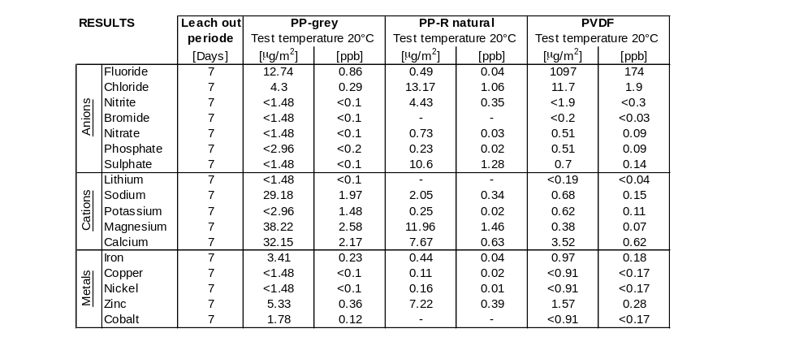

Appendix A Cont.

Total Organic Carbon (TOC) Test

An independent TOC test has been conducted between high purity grades of PolyPure, PP-Grey and PVDF in order to compare amount of extractable TOC levels between systems. The information derived from this test provides useful data in evaluating PolyPure’s suitability for high-purity installations.

Place of measurement: Trace Ionic Analytical Laboratory in the M+W Technology Centre
Kind of measurement: Total organic carbon Analyses (TOC) According to SEMI2840B STD (7d;850C)
Test Description:
- Soak time: 7 Days at 85 °C (185°F)
- Test was performed in Cleanroom class 1
- TOC analyses by TAC-502P system

TOC Test Results:

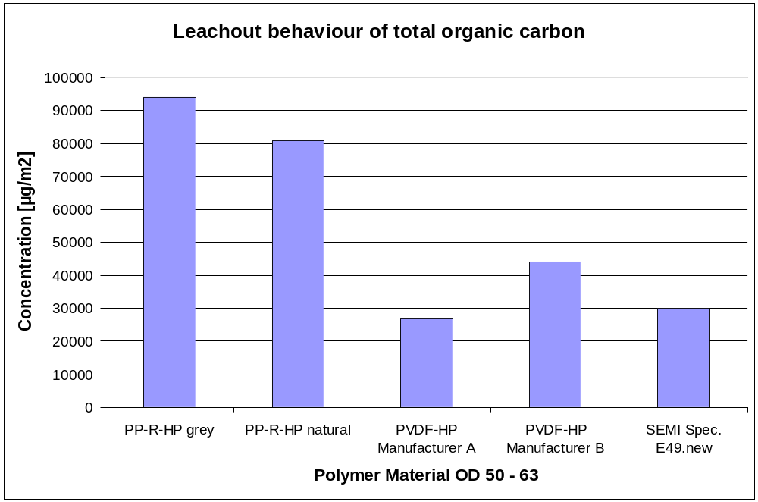

Please contact Asahi/America Technical Department for any additional information not included in this submittal.

